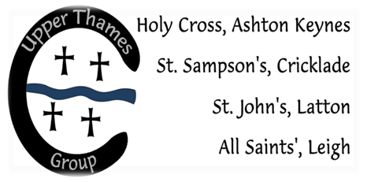

Upper Thames Group of Churches
2021 Wedding Fees
Publication of Banns # | £31
Marriage Service | £464
Verger, heating, copyright, right to video* | £100
Suggested donation* | £50
Basic Cost of a Wedding (with no extras – see below) | £645
Optional Extras*
Church Bells | £120
Organist | £100
Choir | £100

# Banns
- This fee is not payable for couples who have applied for a Common Marriage Licence or Superintendent Registrar’s Certificate.
- Banns only costs £31 for publication of banns + £15 banns certificate = £46

* Notes on fees:
- Verger, heating, copyright & the right to video
This fee covers:
- The cost of opening the church for flower arrangers, setting up for the rehearsal, and a ministry of welcome for guests, ability to play CDs.
- Heating, as even in summer the church can be damp and heating can be required. If heating is not required a refund will be given.
- Small contribution to the cost of the church copyright licence, which allows for the reprinting of hymn words in a church service.
- Permission for an official video to be taken during the service.

- Suggested Donation
All our churches (St Sampson’s Cricklade, Holy Cross Ashton Keynes, St John the Baptist Latton and All Saints Leigh), are maintained entirely by voluntary contributions; we receive no state aid. These beautiful buildings are all historic jewels and are very costly to maintain in a good condition for future generations to enjoy. Your donation helps to cover the costs of professional maintenance, routine care of a listed building, public liability insurance, etc.

- Optional Extras
These payments go directly to pay for the services of the Bell Ringers/Organist/Choir.

Wedding Blessing Service or Renewal of Vows Service
If you are already legally married but wish to host a Wedding Blessing or Renewal of Vows for your friends & family to attend, then we would be delighted to discuss this further. A Wedding Blessing Service or Renewal of Vows in church costs £210. We would also request a suggested voluntary donation of £50 – please see above.

